Topics

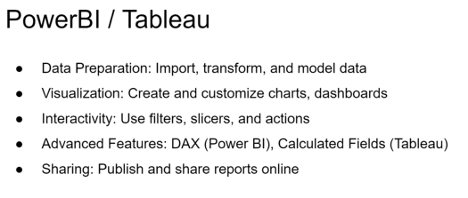

**Tableau**

**Live Connections**

|  |  |
| --- | --- |
| Tableau | Live vs Extract Data Source Demo - [CodeCowboyOrg](https://www.youtube.com/@CodeCowboyOrg) – refresh rate | https://youtu.be/Yy1fh66Z6tg?si=SF40qP0InvyAsnUJ |
| Live vs Extract for Excel file import | https://www.youtube.com/watch?app=desktop&v=-SFfEPYWPP0 |
| [TABLEAU] Performance Recording on Tableau Server | https://youtu.be/aulmhZd2_ks?si=MexHpbBNOexoRRKn |
| Connecting Tableau to SQL Server Database | Running SQL Queries | https://youtu.be/kuDgfwGTeuY?si=n_x4Ti1rj6ZZSI64 |
| Tableau and Custom SQL - plus stored procedure, parameters and initial SQL | sqlbelle | <https://www.youtube.com/watch?v=nEjLMif5Axs> |

**Power BI**

|  |  |
| --- | --- |
| 1. **Prepare Your Data**  * Identify the data sources (e.g., Excel, SQL Server, cloud services like Azure or Google Sheets). * Clean and format the data to ensure accuracy and consistency. | **Salesforce objects -** <https://youtu.be/nfmJfhUKS1M?si=MbeIEQS9BezmmzG6> |
| 2. **Connect to Data Sources**  * Open Power BI Desktop. * Use the Get Data option to connect to the desired data source. * Load or transform the data using **Power Query Editor.** | **Power Query -** <https://www.youtube.com/watch?v=UAFExySaSPY>  [**https://www.slideshare.net/slideshow/power-bi-notes/238411027#55**](https://www.slideshare.net/slideshow/power-bi-notes/238411027#55)  **read page 3** |
| 3. **Data Modeling – Power Pivot**  * Establish relationships between tables if using multiple datasets. * Create calculated columns or measures using **DAX** (Data Analysis Expressions) as needed. | **DAX -** <https://youtube.com/shorts/0FqyGnmS6os?si=Rcad2rSuFaQyV5SI> |
| 4. **Design Visualizations**  * Drag fields to the canvas to create visualizations like charts, tables, and KPIs. * Use **Filters** to narrow down data views as required.   Add slicers for interactivity and drill-down options for detailed analysis. | Drill down - [How to use Drill Down in Power BI | Microsoft Power BI for Beginners - YouTube](https://www.youtube.com/watch?v=ulFY20KTzFQ)  [Filters vs Slicers in Power BI Tutorial (39/50)](https://www.youtube.com/watch?v=d2Z0qIky-Cw)  KPI visual- https://www.youtube.com/watch?v=ehznTSeLdMU&t=133s |
| 5. **Customize the Report**  * Format visuals for consistency (e.g., color themes, labels, titles). * Add **Text Boxes** or images for context and branding. * Create multiple pages if necessary for complex reports. |  |
| 6. **Add Interactivity**  * Use features like tooltips, bookmarks, and slicers to make the report interactive. * Test interactivity to ensure it works as intended. | Drill though - [6.8 How to Use Drillthrough in Power BI | Power BI Tutorial for Beginners | By Pavan Lalwani - YouTube](https://www.youtube.com/watch?v=k-uWcjbLv0E)  **Custom tooltips -** <https://youtube.com/shorts/e7-fepQdTMY?si=nRmvRVj6jPWxwMVj>  Bookmarks - <https://youtu.be/_HTF7Ph7Eqc?si=A_W7wQkocBApadkx> |
| 7. **Save and Publish**  * Save the report as a .pbix file. * Click on the **Publish** button in Power BI Desktop. * Log in to your Power BI Service account. | 8. **Publish to Power BI Service**  * Choose a workspace in Power BI Service to publish the report. * Upload the .pbix file if you skipped the direct publish step. |
| 9. **Share the Report**  * Use **Manage Permissions** to control access to the report. * Share links or embed the report into applications like Teams or SharePoint. * Set up automatic refresh schedules if using live or updated data. | 10. **Monitor and Update**  * Monitor usage metrics to evaluate report performance. * Update the report as needed based on feedback or new data requirements. |
| 11. **Implement Row Level Security**  * Navigate to **Modeling > Manage Roles** in Power BI Desktop. * Create a role and apply filters on tables using DAX expressions (e.g., [Region] = "North"). * Use **View as Role** in Power BI Desktop to test the role functionality. * Publish the report to Power BI Service and assign users or groups to roles under **Security** in the dataset settings. | Parent child hierarchy - <https://www.youtube.com/watch?v=61fUUciDnks> |
| 11. Power BI services and Licenses  * Power BI Reporting Server * Power BI Service Desktop * Power BI Mobile * Power BI Embedded |  |
|  |  |
|  |  |

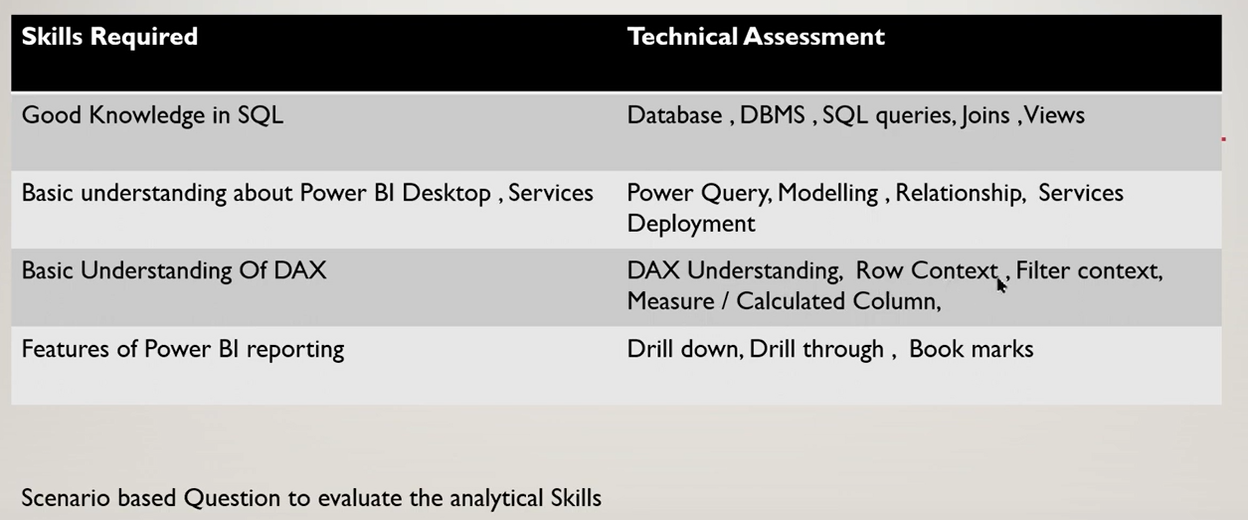

https://youtu.be/Om_DqqvZWOM?si=AnH_wippJghez_OG

* Sample project work
* Filters / slicers, actions

Case Studies

### **Advanced Power BI Technical Interview Questions and Answers**

### **1. How do you optimize Power BI performance for large datasets?**

**Answer:**

1. **Use DirectQuery or Import Mode Wisely:** Choose DirectQuery for real-time data and Import for better performance.
2. **Granularity** Pre-aggregate data at the source level to reduce rows and columns.
3. **Reduce Cardinality:** Remove unnecessary columns or high-cardinality columns.
4. **Efficient Data Modeling:**
   * Use Star Schema instead of Snowflake.
   * Set appropriate relationships and avoid bidirectional filtering unnecessarily.
5. **DAX Optimizations:**
   * Replace complex measures with calculated columns when possible.
   * Avoid using CALCULATE and FILTER unnecessarily.
   * nested functions
6. **optimize SQL queries and data workflows**

### **2. Explain the difference between calculated columns and measures in Power BI. When would you use one over the other?**

**Answer:**

* **Calculated Columns:**
  + Created at the row level and stored in the model.
  + Use when you need new fields for filtering, slicing, or categorizing.
  + Example: Profit Margin = (Sales - Cost) / Sales.
* **Measures:**
  + Calculated dynamically during runtime.
  + Use for aggregations or calculations based on interactions and filters in visuals.
  + Example: Total Sales = SUM(Sales).
* **When to Use:**
  + Use **calculated columns** for static data transformations.
  + Use **measures** for aggregations and dynamic calculations in visuals.

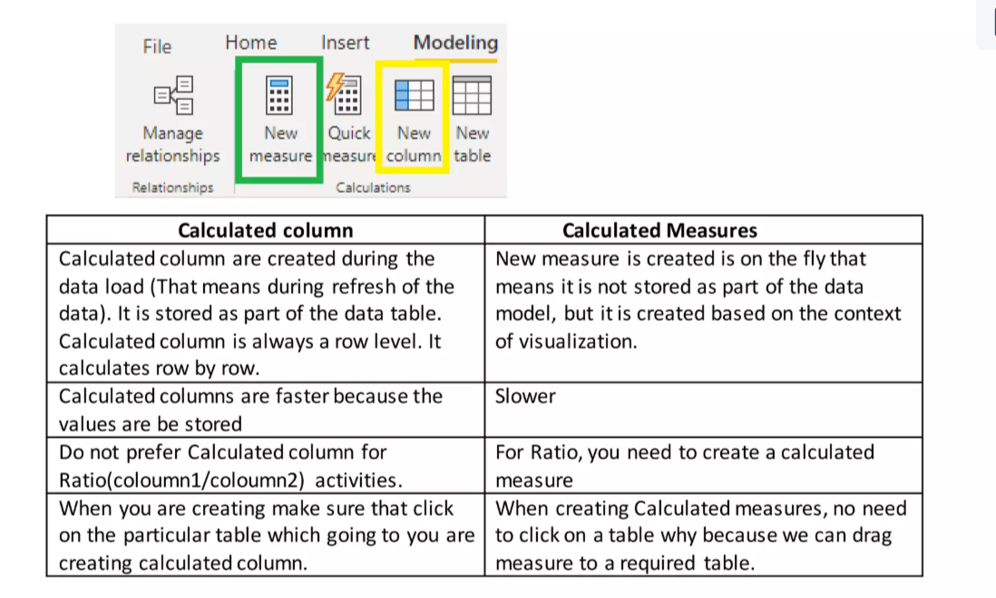

### **3. What are the different types of joins in Power BI, and how do they work in Power Query?**

**Answer:**

* **Inner Join:** Includes only matching rows from both tables.
* **Left Outer Join:** All rows from the left table and matching rows from the right.
* **Right Outer Join:** All rows from the right table and matching rows from the left.
* **Full Outer Join:** All rows from both tables, matching where possible.
* **Anti Joins:**
  + Left Anti Join: Rows in the left table not present in the right.
  + Right Anti Join: Rows in the right table not present in the left.

**Implementation in Power Query:**

1. Navigate to **Home > Merge Queries**.
2. Select the join type from the dropdown.
3. Choose columns to match between tables.

### **4. How do you handle dynamic filtering in Power BI?**

**Answer:**

* Use **Slicers** or **Filters:** Add slicers on the report page to allow users to filter dynamically.
* Use **Row-Level Security (RLS):**
  + Create roles with filters (e.g., [Region] = "North").
  + Assign users to roles for tailored views.
* **Dynamic Measures:**
  + Use DAX to create measures that adapt based on user selections.
  + Example:

Sales by Selection =   
SWITCH(  
    TRUE(),  
    SELECTEDVALUE(Region) = "North", SUM(Sales[North Sales]),  
    SELECTEDVALUE(Region) = "South", SUM(Sales[South Sales]),  
    SUM(Sales[Total Sales])  
)

### **5. How would you debug a DAX expression in Power BI?**

**Answer:**

* **Check Intermediate Results:**
  + Break the DAX formula into smaller pieces and evaluate them using **RETURN**.
  + Example:

VAR TotalSales = SUM(Sales[Amount])  
RETURN TotalSales

* **Use DAX Studio:**
  + Analyze query execution steps and performance bottlenecks.
* **Evaluate in a Table:**
  + Test the formula by creating a table visual with relevant fields and measures.
* **Use Error Messages:**
  + Pay attention to Power BI's error messages to identify syntax or logic issues.

### **6. What is the use of aggregations in Power BI, and how do you implement them?**

**Answer:**

* **Purpose:**
  + Improve performance by pre-aggregating data.
  + Reduce the dataset size by storing summarized information.
* **Implementation:**
  + Enable **Manage Aggregations** in Power BI Desktop.
  + Specify columns for aggregation (e.g., SUM, COUNT).
  + Configure relationships with detailed data tables.

### **7. Explain the use of bookmarks in Power BI and provide a practical example.**

**Answer:**

* **Purpose:**
  + Save and restore specific views of a report.
  + Enhance navigation and storytelling.
* **Use Case Example:**
  + Create bookmarks for different filter states (e.g., Sales by Region, Sales by Product).
  + Add buttons to navigate between bookmarks for an interactive report.

### **8. How does Power BI handle time intelligence, and what DAX functions are commonly used?**

**Answer:**

* Power BI includes **Date Tables** and DAX **Time Intelligence Functions** for calculations over time.
* Common DAX Functions:
  + **TOTALYTD**: Year-to-date calculations.
  + **PREVIOUSMONTH**: Returns results for the previous month.
  + **SAMEPERIODLASTYEAR**: Compares values from the same period last year.
  + **DATESINPERIOD**: Aggregates over custom time frames.

### **9. How do you implement Row-Level Security (RLS) in Power BI?**

**Answer:**

* **Steps:**
  1. Go to **Modeling > Manage Roles**.
  2. Create a role and define filters on tables (e.g., [Region] = "North").
  3. Test roles in the Power BI Desktop by switching to **View as Role**.
  4. Publish the report and assign roles to users in the Power BI Service.

### **10. Explain the difference between KPI and Card visual in Power BI. When would you use each?**

**Answer:**

* **KPI Visual:**
  + Displays a key metric along with its trend and target comparison.
  + Use for tracking performance against a goal.
* **Card Visual:**
  + Displays a single value (e.g., total sales).
  + Use for simple summaries or standalone metrics.

# PL 300

|  |  |
| --- | --- |
|  | |
| **1. Prepare the Data (15–20%)**  * Get data from various sources (SQL Server, Excel, SharePoint, etc.). * Clean, transform, and load data using **Power Query**. * Profile and examine the data for inconsistencies. * Optimize data for performance and storage. | |
| Data source settings in Power query   * Clearing permissions * Editing permissions * Modifying file path   Import instead of Direct Query benefits:   * Q&A support * Quick insights PBI service support   Direct Query benefits   * Minimize local disk space * Minimize data refresh   “Time out expired” (available bandwidth and low latency)   * Divide SQL to separate data sources   Anamolies of 10,000 excel rows   * Column Profile view * Power Query editor * Profiting status > entire dataset   Outliers in Text column   * Top and Bottom in Value distribution   M code   * Advance Editor in Power Query Editor   Remove and no new columns   * Select Columns, Remove Other columns   Flatten Parent Child Hierarchy  ExceptPath, PathItem CrossJoin | Custom R visual   * install R on your computer. * Configuring global R scripting options * Enabling the script visuals option in the Visualization pane of Power BI Desktop * Creating a custom R visual by using Power BI Desktop has no dependency on enabling preview features.   custom Python visual   * install Python on your computer. * configure the global Python scripting options in Power BI Desktop. * Enabling the script visuals option in the Visualization pane of Power BI Desktop * Creating a custom Python visual by using Power BI Desktop has no dependency on enabling preview features.   Power BI dataset discoverable   * Certify the dataset * Promote the dataset   The shared folder requires a gateway as it is not available to the internet.  SharePoint Online, OneDrive, and OneDrive for Business, refreshed as cloud data sources without a gateway.  source table does includes data but not import   * Use the CAST function in the SQL statement.   benefit of using a Power BI dataset instead of multiple report databases   * reduces the number of datasets, refreshes, and storage requirements   scheduled refresh for the dataset by using Microsoft 365 credentials.   * One drive for Business * SharePoint – Team Sites   When importing data from an Excel workbook into Power BI, you receive the error message: “We couldn't find any data formatted as a table.”   * select the data you want to import, create a table, and save the change |
| **2. Model the Data (30–35%)**  * Design and develop **star and snowflake schemas**. * Define and create **calculated tables, columns, and measures using DAX**. * Implement relationships, hierarchies, and role-based security. * Optimize model performance by managing aggregations. | |
| IND JAN22 FEB22  US JAN22 FEB22  UK JAN22 FEB22   * Unpivot Other columns   Pivot Columns  SalesOrder SalesOrdDetails SalesID   * Merge in Left join   Cardinality to avoid for ambiguity   * Many to many   to develop a quick measure   * Calculations * Fields | relationship from a fact table to a dimension table   * Many-to-one   From the Model /Report view, right-click and select Create hierarchy.  Merge the queries to create a single loaded table for Product.   * create a dimension for use in a star schema   which two model items can be created using the DAX language   * calculated table * numeric range parameter |
| **Time intelligence and Calendar** | |
| Auto generated daytime data type columns   * Mark as date table for the calendar table * Disable auto date time from the current file.   DAX quick measure not against direct query.   * Time in intelligence   analyze data on a yearly, quarterly, monthly, weekly, and daily basis when Auto date/time setting is disabled in both global and current   * Add a separate date dimension table | Current Inventory Count returns only the current total number of inventory items   * LASTDATE   create a date table and populate with a range based on the earliest and latest date within the dataset   * CALENDARAUTO   M-language to define a common date table spanning a period of 10 years   * #duration   a measure that always provides the value of total sales for the year 2022 in combination with the SUM   * CALCULATE |
| **3. Visualize and Analyze the Data (25–30%)**  * Build and format **interactive reports and dashboards**. * Implement **advanced visuals** like KPI indicators, slicers, and maps. * Apply **conditional formatting, bookmarks, and tooltips** for better insights. * Perform **statistical analysis using Power BI visuals**. | |
| Using DAX columns but not DAX calculated measure.   * As a filter on this page. * As an item in the fields well   using variables in DAX measures.   * Improve overall performance. by cache * Improve overall readability   Best selling products   * TOPN   Alerts are available with KPI visuals, gauges, and cards.  Themes use the JSON file format  You plan to optimize the performance of Power BI Desktop queries against a remote data source.   * the Reduce number of queries sent by Query reduction setting   You need to disable the default behavior that automatically applies cross highlighting and filtering of visuals within the same report.   * the Reduce number of queries sent by Query reduction setting   visual that is being cross-highlighted.   * the filtered (cross-highlighted) data | 2OrMoreDimensionsCrossHighlights   * Matrix   Conditional formatting   * Matrix, Tables   Sequentially connected stages   * Funnel   Employees ranking chart and overall trends   * Ribbon   Stacked column charts remove date hierarchy   * Remove date from X axis   create the histogram   * ✅The Bin group type is an auto grouping of items * ✅a Numerical column * ❌ List group type is a manual grouping   Edit interactions   * Filter and highlight   Less than 1% of its value   * filter   Bookmark toggle visuals   * ❌ Data * ❌ Current Page * ✅Display   Bookmark hide a visual   * Hide in Selection pane |
| **4. Deploy and Maintain Assets (20–25%)**  * Publish reports to **Power BI Service** and configure refresh schedules. * Set up and manage **row-level security (RLS)**. * Implement **Power BI dataflows** and workspaces. * Troubleshoot performance issues and optimize reports. | |
| Data refresh using Microsoft 365 credentials   * One drive for business * Sharepoint – teams sites   Change server name in PBI service   * Create parameter * Update server source as parameter   UPN equals to user principal name.   * DAX expression filter * Create a role   Data engine cache will not impact the test results.   * Connect DAX studio to the data model. | Power BI dashboard   * Power BI service   Pinned visuals for dashboard   * Custom visual, images   Notification   * Email, Notification centre   Row level security   * Create a role   create a role from   * Model view * Report view   validate that the RLS implementation   * In the Report view, activate the View as feature.   Update workspace with least privileges   * Admin |
| **5. Work with Power BI Service & Advanced Features (5–10%)**  * Configure **subscriptions and alerts** for report updates. * Implement **AI-powered insights** like Q&A and Smart Narratives. * Integrate Power BI with **Power Automate and Power Apps** for automation. | |
| Improve Q&A search abilities  * Add linguistic schema to dataset * Add synonyms to model fields   Native AI visual  explain correlations for a metric   * Key influencers visual   Visual NOT in the workspace   * Ask a question about your data   Workspace refreshes per day   * 8   You need to delegate the task to update workspace metadata. The solution must use the principle of least privilege.  Which role should you use?   * The Admin role is the only one that has the permission to update workspace metadata.   You need to provide Power BI Service users access to the data sources without exposing the on-premises Microsoft SQL Server databases servers directly to the internet.   * An on-premises gateway is designed to allow multiple users to access multiple data sources. An on-premises data gateway only allows one user to access multiple data sources. A virtual network data gateway is designed to allow multiple users to access multiple online data sources. However, it isn’t installed locally and only works with data sources secured by virtual networks. | data engine cache   * Connect DAX Studio to the data model.   configure a Microsoft 365 group whose SharePoint Online document library is available to workspace users once the workspace is created.   * Workspace OneDrive   The Workspace OneDrive setting allows you to configure a Microsoft 365 group whose SharePoint Online document library is available to workspace users once the workspace is created. The Allow contributors to update the app for this workspace setting is meant to provide additional permissions for workspace contributors. The Develop a template app setting allows you to set up a template app workspace. The license mode allows you to choose between Pro, Premium per user, Premium per capacity, and Embedded licensing.  Your company has a SharePoint server located in a datacentre in Montreal.  You plan to create a report in the Power BI service that will use Microsoft Excel files stored on the SharePoint server.  that the dataset for the report can automatically refresh daily.   * An on-premises SharePoint server requires the use of a Power BI gateway since it’s an on-premises data source. VPN-based solutions would provide connectivity to an Azure virtual network, but not Power BI service. Azure Data Box is a solution for migrating data to Azure, which is not applicable in this scenario. |
|  |  |